PortSwigger Lab POC - 05-password-reset-broken-logic

Lab 5 — Password reset broken logic

Step 1 — Trigger password reset for wiener
Go to **Forgot password?** → enter `wiener` → open reset link from email.

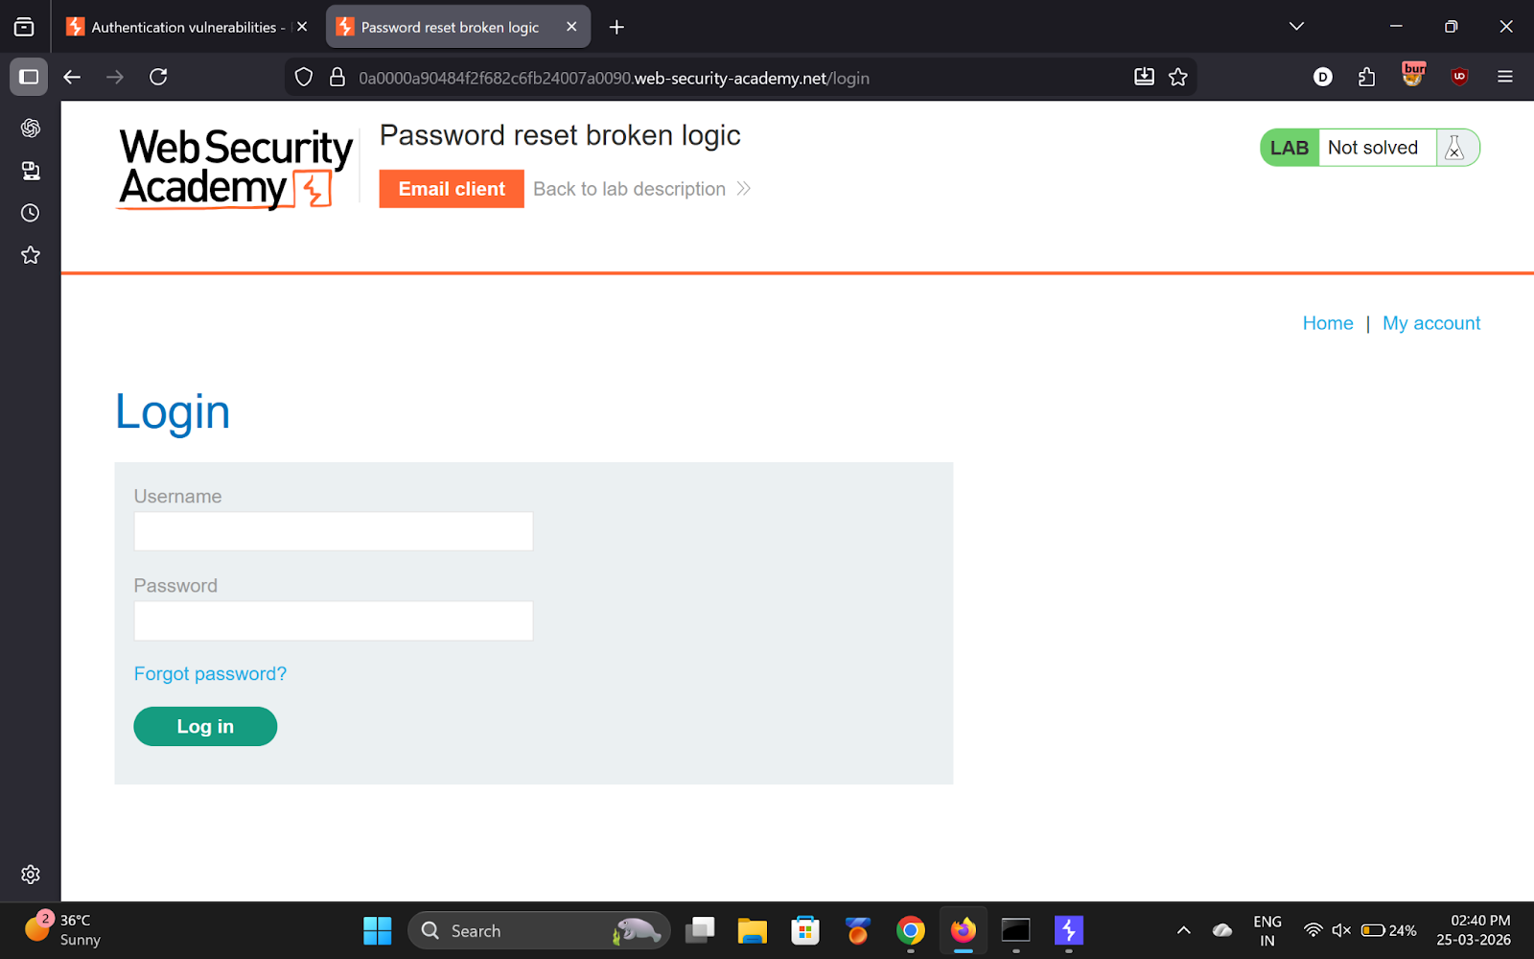
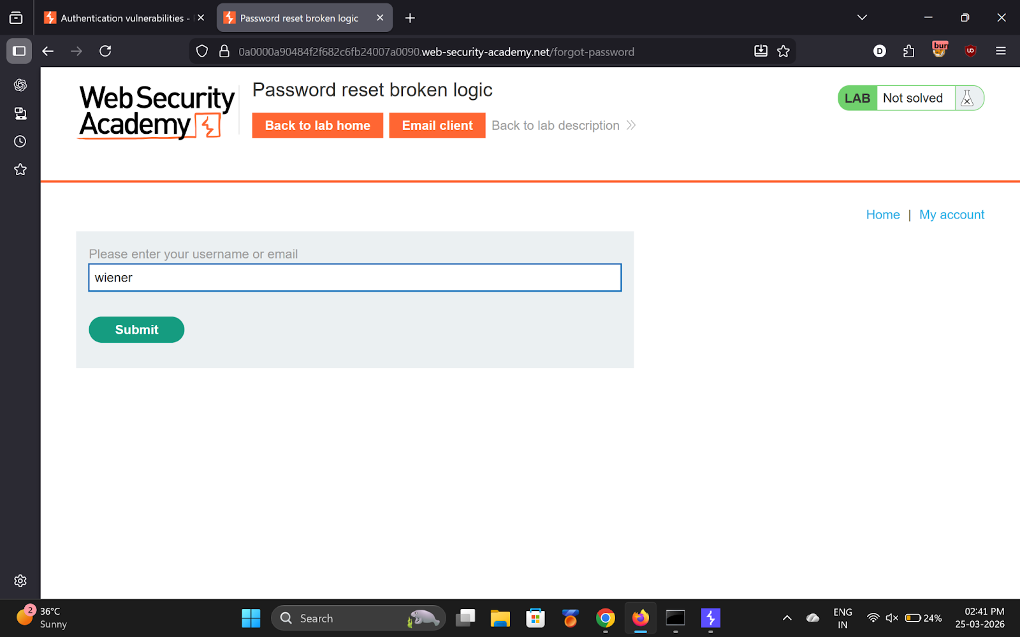

---

Step 2 — Submit new password, capture in Burp
Find `POST /forgot-password?temp-forgot-password-token=XXXX` in HTTP history.

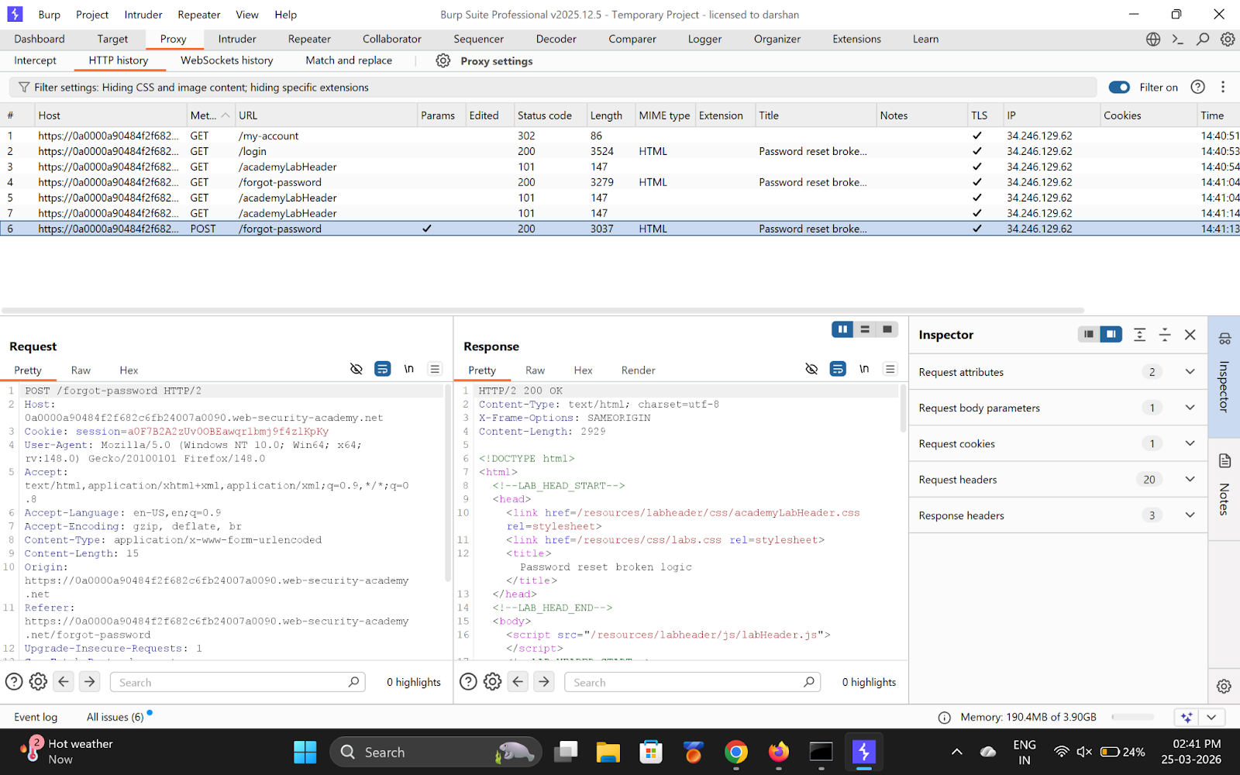
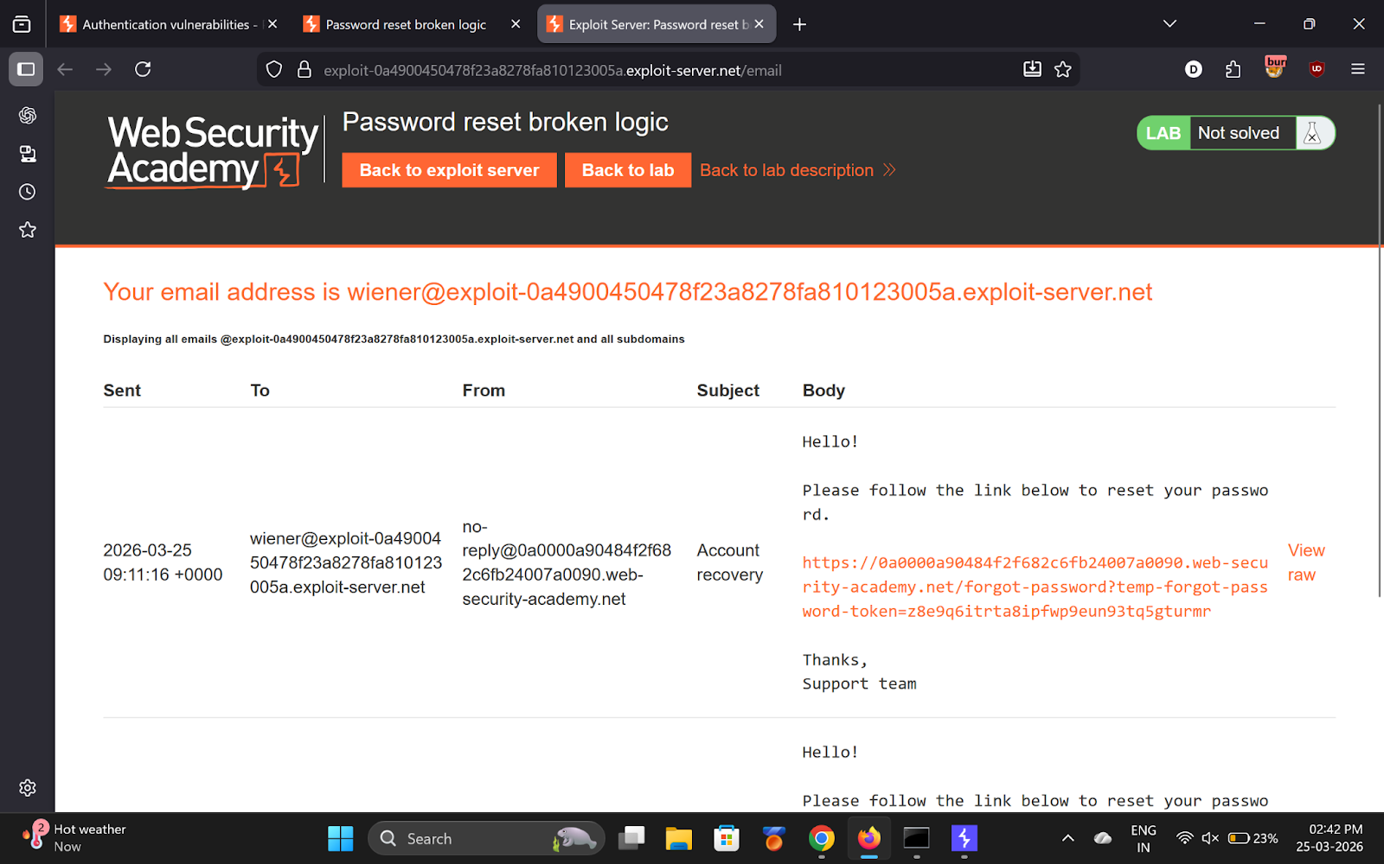

---

Step 3 — Send to Repeater
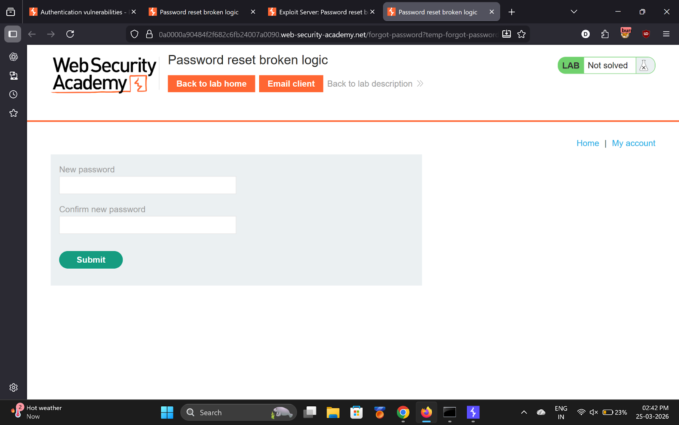

---

Step 4 — Break the logic
Modify the POST body:
- `temp-forgot-password-token=` ← **clear the token**
- `username=carlos` ← **change username**

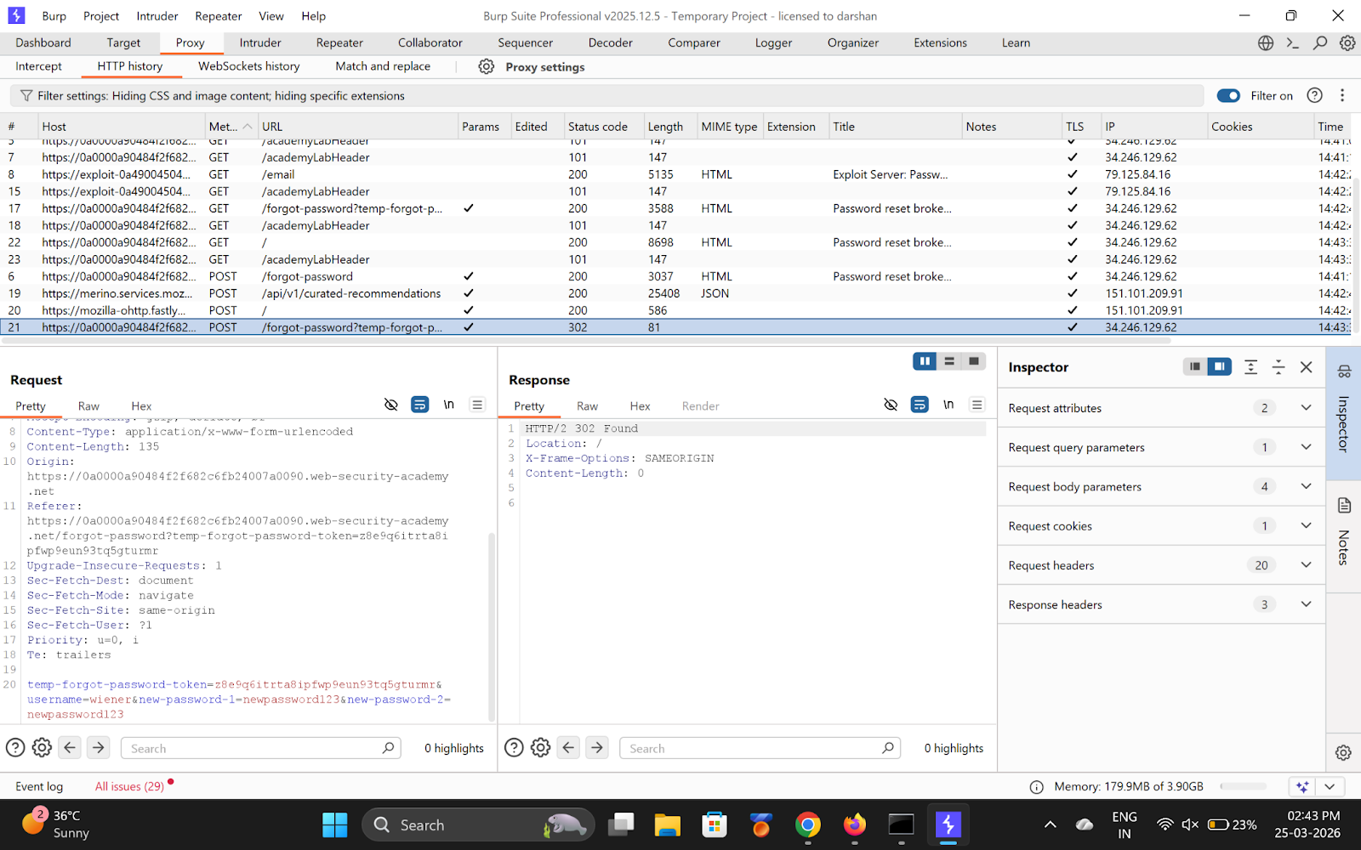
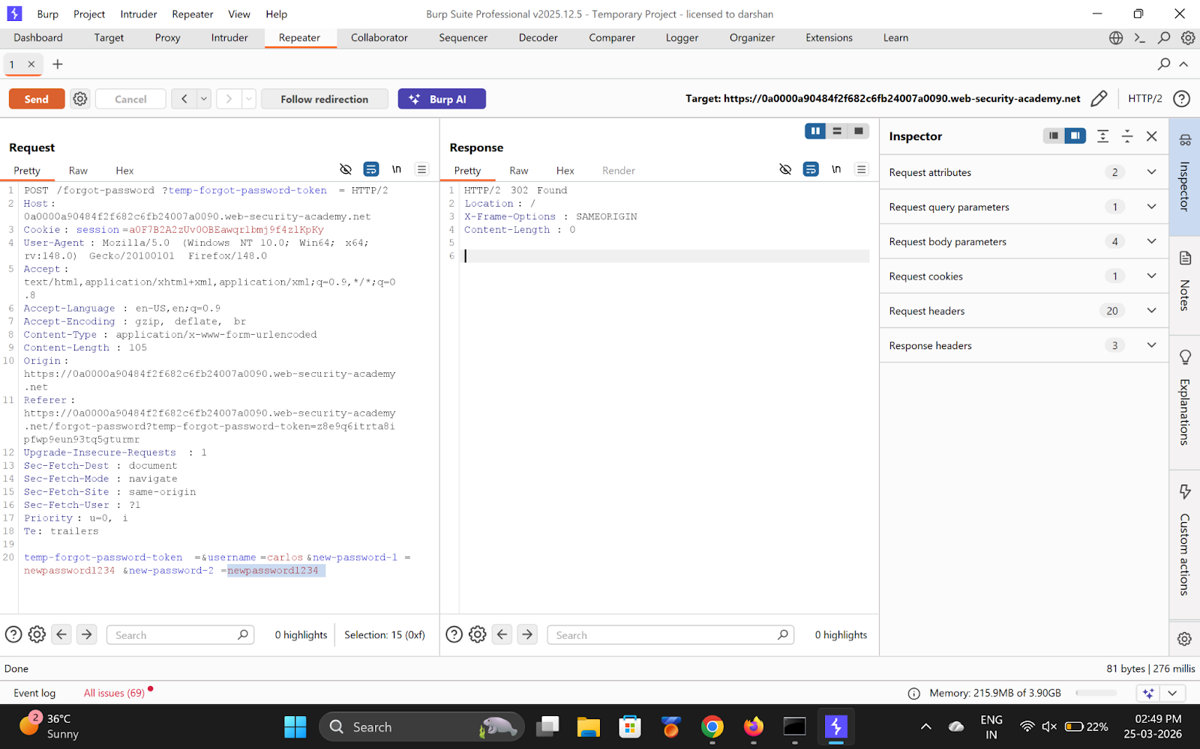

---

Step 5 & 6 — Send and login as Carlos
Response: **200 OK** → attack worked.

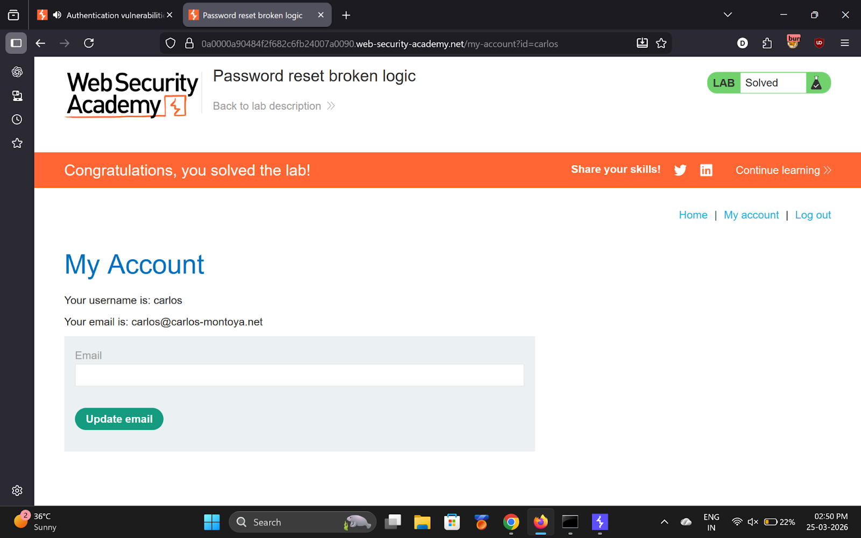

Login using `carlos` with the password you set.

---

✅ Result
Lab solved!

💡 Key Takeaway
Never trust the username from the POST body — always derive it from the validated reset token.

